Operation Manual

HM801 Transformer Oil BDV Tester

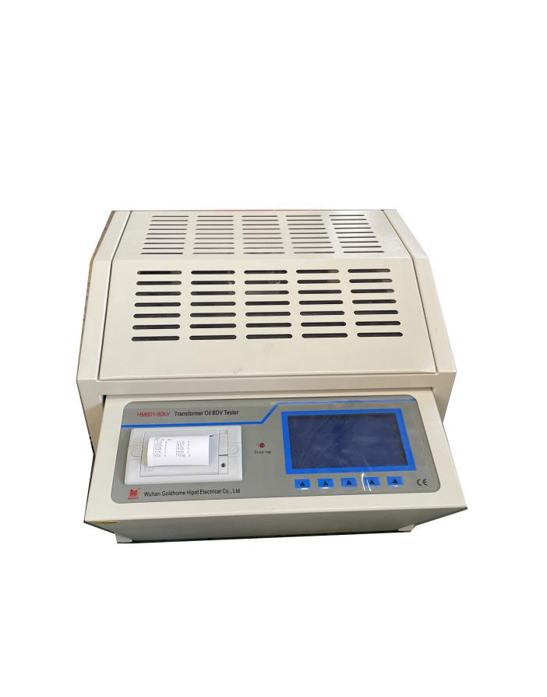

WUHAN GOLDHOME HIPOT ELECTRICAL CO.,LTD
Tel.：+86-13720265142 Fax：+86-27-84625205
Email：goldhome03@cablehipot.com Web.: www.hvcablehipot.com
Add.: No.A25-1, Huading Mould Industrial Park, Hannan, Wuhan, Hubei, China

Content

Before the word -- -- -- -- -- -- -- -- -- -- --- -- -- -- -- -- -- -- -- -- -----3
I. summary -- -- -- -- -- -- -- -- -- -- -- -- ------.-- -- -- -- -- -- -- -- -- --4
II. Instrument characteristics -- -- -- -- -- -- ---- -- -- -- -- -- -- -- -- -- 5
III.Technical indicators -- -- -- -- -- -- -- -- ----- -- -- -- -- -- -- -- -- -- 6
VI.Conditions of use -- -- -- -- -- -- -- -- -- ------ -- -- -- -- -- -- -- -- --7

V. Panel shows -- -- -- -- -- -- -- -- -- -- -- -- --- -- -- -- -- -- -- -- -- ---8

VI.Steps diagram -- -- -- -- -- -- -- -- -- -- -- ---- -- -- -- -- -- -- -- -- -- 9
VII.matters needing attention -- -- -- -- -- ---- -- -- -- -- -- -- -- -- -- 13
VIII.Simple troubleshooting -- -- -- --- --- ---- -- -- -- -- -- -- -- -- --14

IX.After-sales service -- -- -- -- -- -- -- -- -- -- -- -- -- -- -- -- -- -- -- 17

Before the speech

Dear users:
Thank you for choosing the Dielectric strength tester! For the convenience of you familiar with the instrument as soon as possible as soon as possible, we provided the detail operation manual, from which you can get the product introduction, the use of methods, equipment performance, and security considerations, and many other aspects.

Before the first use of the instrument, please be sure to read the manual carefully, and according to the manual of instrument operation and maintenance, this will help you better use of the product, and it can prolong the service life of the instrument.

At writing manual, although we in line with the scientific and rigorous attitude for work, and that the information provided in this manual are correct and reliable.However, even Homer sometimes nods, this manual also hard to avoid can have errors and omissions.If you find the errors in the manual, please be sure to in spite of being very busy toglance take time, try to let us know as soon as possible, and please supervise us correct errors quickly!The company all staff will be appreciated!

The company reserves the right to improve the instrument use function, such as found in the process of using the function of the instrument and operation manual to introduce inconsistencies, please based on the actual function of the instrument shall prevail.We hope that the instrument can make your job easier, happy, to you in the busy work realize office automation of relaxed and happy feeling!
When you are satisfied with our instruments, please recommend to your friends!When you have valuable advice and Suggestions to this instrument, please be sure to contact us, we will try our best to give you a satisfactory answer.Thank you again for your support to our company!

I. Summary

As is described series fully Automatic insulating oil pressure teste is my company all the scientific and technical personnel .In order to satisfy the needs of different users, this series of instruments can be divided into single cup and three cups and cup type, etc.The instrument is simple, modelling is beautiful and easy.Due to adopt fully automatic digital computer control, so the measurement of high precision, strong anti-jamming capability, safe and reliable.

II. Instrument characteristics

1. The instrument uses large capacity single-chip microcomputer control, stable and reliable in work.

2. The device has wide scope of the watchdog circuit to prevent the death machine;

3. Various operation options, two national standard methods and custom operation, can adapt to different user's various choices;

4. The instrument oil cup is cast in a special glass, which eliminates the interference phenomenon such as oil leakage;

5. The unique high voltage end sampling design of the instrument allows the test value to go directly into A/D converter, avoiding the error caused by the simulation circuit and making the measurement results more accurate;

6. The instrument has the function of flow, overpressure, short circuit, etc., and has the strong anti-interference ability and electromagnetic compatibility;

7. Portable structure, easy to move, indoor and outdoor use is very convenient.

III. Technical indicators

1. Booster capacity：1.5kVA

2. Booster speed：2.0kv/s, 3.0kv/s, optional Poor miss：0.2kV/s

- Output voltage：0 ~ 80kv

4. Power distortion factor：＜1%

5. Display mode：Large screen LCD character display

6. The electrode spacing：Standard 2.5 mm

7. Overall dimensions：430 mm long;350 mm wide;370 mm high

8. Instrument weight：26 kg

IV. Conditions of use

1. The environment temperature：0～40℃

2. Relative humidity：≤ 85%

3. Working power supply：AC 120V

4. Power frequency：60 Hz

5. Power consumption：＜200 W

V. Description of chassis and panel parts

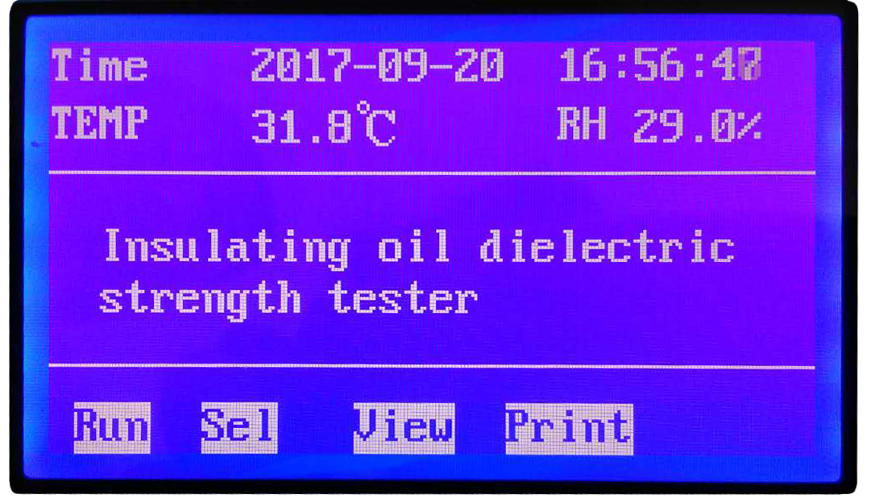

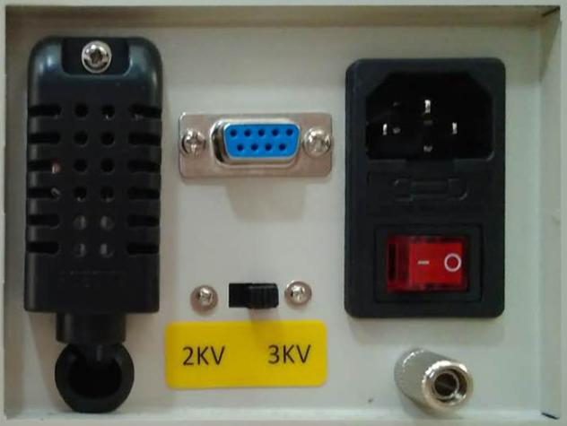

- The LCD panel：Display date, time, operating parameters, test results, operation menu tips, etc;

2. The function keys：Select set operation parameters;

3. The printer：Print test results;

4. Toggle switch：Choose a different rate of pressure rise;

5. Indicator light：The light indicates that the relevant operation steps are in progress;
6. Oil cup lid：After opening, place or remove the oil cup, and test it after closing;
7. Temperature and humidity sensor：The temperature and relative humidity are measured and converted to digital signals;
8. Ground column：Reliable ground connection column;
9. The power outlet is on the switch：Good connection of AC220V 50Hz power cord;
10. Press the switch：Press to open or close the lid；
11. High pressuremark：A triangle sign of high voltage danger.

VI. Diagram of operation steps

1. Plug the power cord, turn on the power switch, and LCD screen displays the boot page (figure 1)

Figure 1. On the page

2. Under the page of figure 1, press the set key to enter the next level page (figure 2).
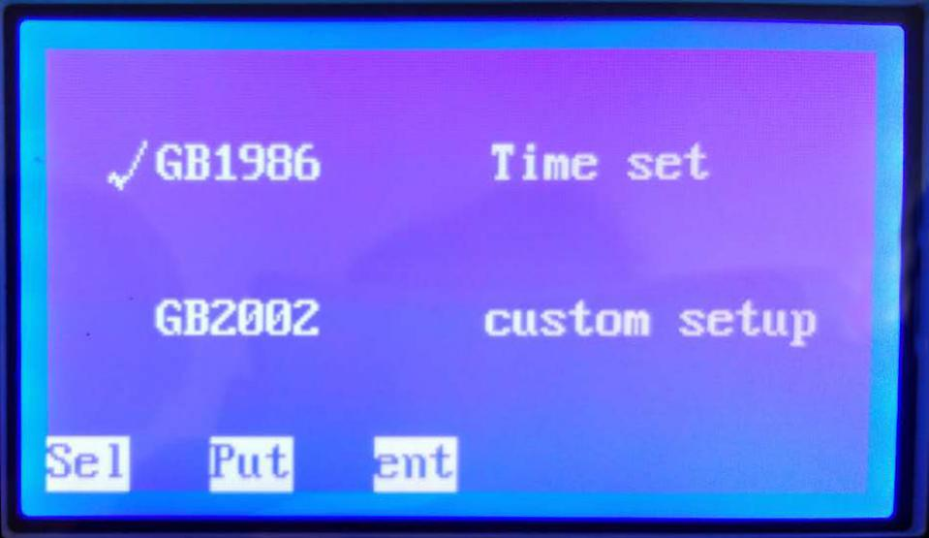

Figure 2. Choose the child pages
3. In figure 2 page, press the select key to move the cursor) GB1986, press the ok button to enter national standard 1986 set child pages (figure 3).
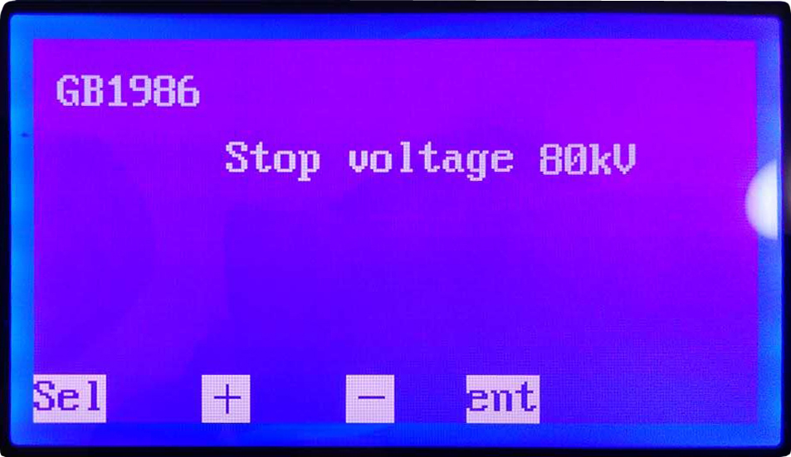

Figure 3. GB1986 child pages
Under the page of figure 3, the stop - rise voltage is set by + or - key, and the default value is 80 kV, and the range of optional range is 10 kV ~ 80 kV (the gear increment of 10 kV).After selecting, press the confirmation key to return the boot page and press the start button to test.
If there is no reliable grounding, instrument displays grounding, please!And send out alarm.Should turn off the power at this moment, good earthed again after operation;
Note: Figure 3 page selection key is reserved for multi-cup selections!
4. In figure 2 page, press the select key to move the cursor) GB2002, press the ok button to enter national standard 2002 set child pages (figure 4).
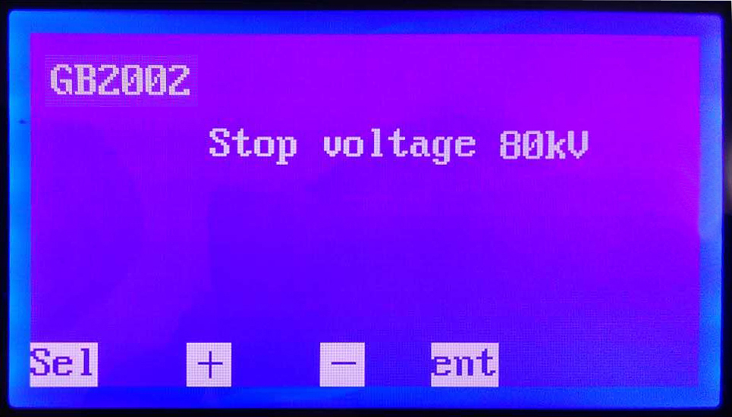

Figure 4. GB2002 child pages
In figure 4 pages, press the + or - button set ting up voltage, its default value is 80 kV, optional scope of 10 kV ~ 80 kV (gear increment 10 kV).Choose good after press the confirmation key to return to boot page, press the start key for testing.

If there is no reliable grounding, instrument displays grounding, please!And send out alarm.Should turn off the power at this moment, good earthed again after operation;

Note: Figure 4 page selection key is reserved for multi-cup selections!

5. In figure 2 page, press the select key to move the cursor) time Settings, press the ok button to enter time set child pages (figure 5).
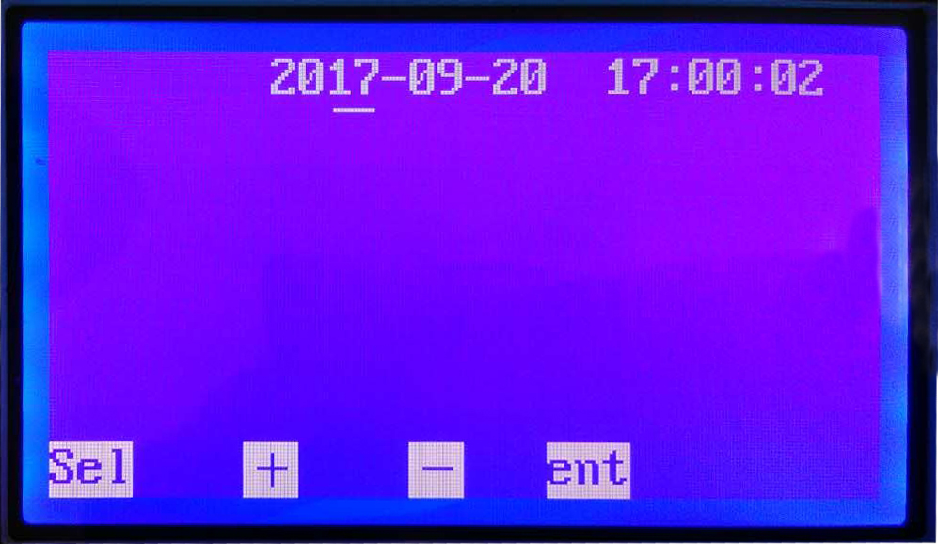

Figure 5. Time Settings page
Press select key to move the cursor - to year, month, day, hour, minute, press + or - button to select the specific number, press the confirmation key, and return the boot page;

- In figure 2 page, press the select key to move the cursor) Settings, press the ok button to enter the custom set child pages (figure 6);
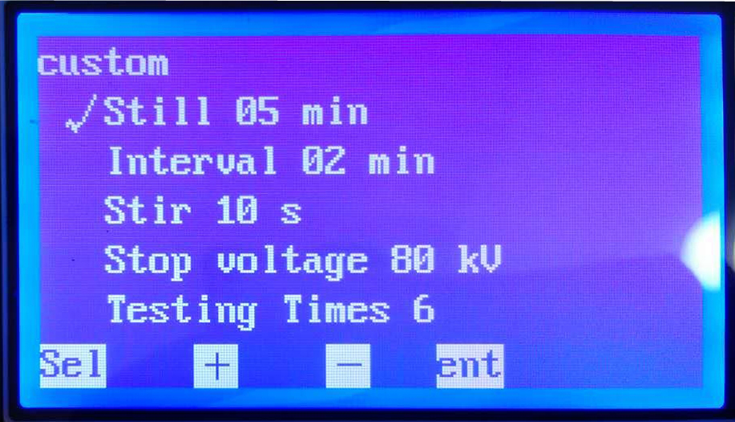

Figure 6. A custom Settings page
In figure 6 pages, press the select key move the cursor to the corresponding option, then press the + or - key parameters can be set.Among them:

Let stand time：Let stand for 15 min, the default value is optional range 1 ~ 15 min (gear increment 1 min);

Interval time：Time interval defaults to 5 min, optional range 1 ~ 10 min (gear increment 1 min);

Mixing time：Stir the default value is 10 s, optional range 5 ~ 90 s (gear incremental 5 s);

Stop up the voltage：Stop up the default value is 80 kV voltage, the optional range of 10 ~ 80 kV (gear increment 10 kV).When the instrument booster to stop rising voltage Time will cease to step up and into the state.If no breakdown for 50 s, the instrument will default to the current stop up voltage of insulating oil breakdown voltage;

On number：On the default value is 6, optional range 1 ~ 6 times (gear increases 1 times);Set after press ok button to return to the start page, press the start key for testing.

7. Every time the breakdown voltage and the number of cycle of automatic storage, and after the measurement shows that the test finished, then press the ok button to return to the start page (figure 1), press to print or display into the oil cup each average value and the breakdown voltage of storage record (figure 7).
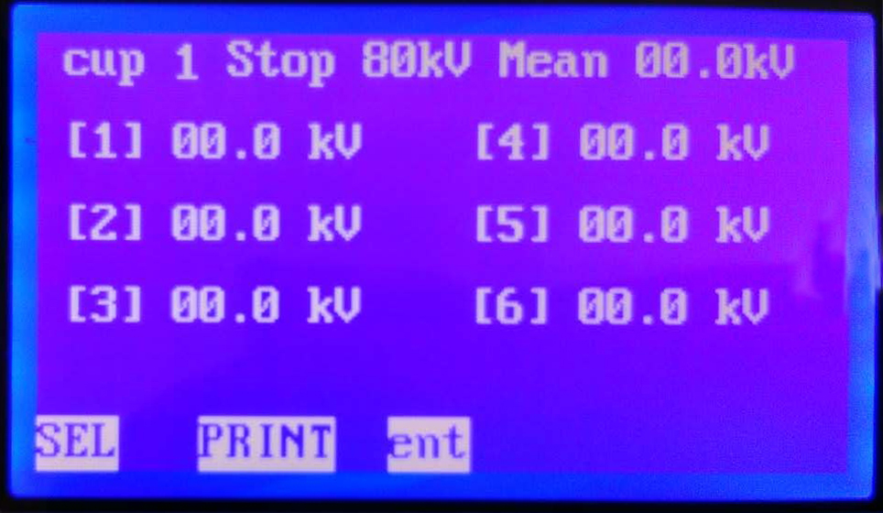

Figure 7 shows the page
Press print to print the test results, according to the confirm button to return to boot page (figure 1).

VII. Matters needing attention

1. Before using this instrument, be sure to read this operation manual;

2. The instrument operators should be familiar with electrical equipment or analysis instrument of general use common sense;

3. The instrument inside and outside all can use, but should avoid the rain, corrosive gas, high dust, high temperatures or direct sunlight and other places use;

4. The oil cup should be kept clean.During the outage, should add enough dry qualified insulating oil immersion, keep oil cup will not be affected with damp be affected with damp;

5. Continuous use electrodes in after a month, should be a check, inspection electrode gap with and without change, use a magnifying glass to observe electrode surface had dark phenomenon, if has this phenomenon, application of silk cloth to wipe the electrode surface, and readjust the electrode gap and make it conform to the requirements;

6. The maintenance and commissioning of the instrument shall be completed by the professional;

7. After turning on the power, the operator is forbidden to touch the oil cup box cover to avoid the danger of electric shock!

8. Before turning on the power supply, should check carefully whether the cable is firm, instrument shell must be reliable grounding.

9. The instrument is in use process, if discovery is unusual should immediately cut off power supply.

VIII. Simple troubleshooting

1. Boot no reaction：Check whether the power cord is plugged in properly and check whether the safety tube is intact;

2. No booster：Check whether the cap of the oil cup box is covered;

3. Normal wear without breakdown：Check if the setting limits the boost speed;

4. No display after breakdown：Check the oil cup for dirt;

5. The printer is out of paper：Check if the printer has any paper;

6. Replace the printer paper：The printer has installed the printer when it leaves the factory.If the printing paper is used, the new printing paper will be installed.

Note:The introduction of the printing paper replacement process is as follows

(1) Press the round button on the front cover of the printer;

(2) put the paper into, and pulled out a piece (beyond a little tearing teeth), pay attention to put the paper up, at the same time pay attention to the direction of the paper (paper pulled out after the paper roll the lateral face the print head).

(3) close the hatch cover paper, print head go paper typed axial compression, hold in the print head after go back to the print head paper axial compression.

IX. After-sales service:

Instruments within one year from the date of purchase, the product quality problem free warranty, life-long maintenance and technical services.If it is found that the instrument is not normal or defective, please contact with our company, in order to arrange the most convenient and effective processing scheme for you.

